**Event proposal**

* **YogYakarta**
* **Malang**
* **Sumba**

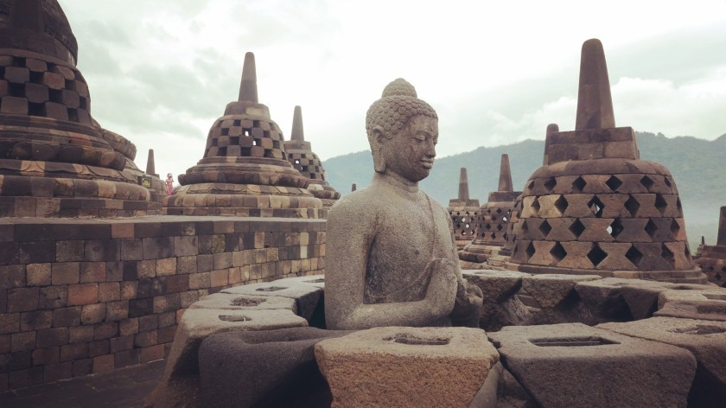

**YOGYAKARTA**

**Spiritualism in Yogyakarta (Jogja): A Blend of Tradition and Mysticism**

Yogyakarta (often called **Jogja**) is not only known for its cultural richness and historical significance but also for its **deep spiritual traditions**, which are a unique blend of **Javanese mysticism**, **Islamic practices**, **Hindu-Buddhist heritage**, and **local animist beliefs**.

**1. Kejawen: Javanese Spiritual Belief System**

One of the most prominent spiritual philosophies in Yogyakarta is **Kejawen**. This is a mystical belief system that:

* Emphasizes **inner harmony**, **meditation**, and **self-control**.
* Mixes elements from **Islam**, **Hinduism**, **Buddhism**, and **local ancestral worship**.
* Is not a formal religion, but a **spiritual path** to understanding the universe and achieving inner peace.

Kejawen often involves:

* **Rituals (ritual selamatan or slametan)** to connect with ancestors and seek protection.
* **Meditation and fasting** for spiritual clarity.
* **Sacred sites**, such as Mount Merapi, Imogiri Royal Cemetery, and Parangtritis Beach, believed to be spiritually powerful.

**2. Syncretism with Islam**

In Yogyakarta, most people are Muslims, but many still practice **a form of syncretic Islam**, blending Islamic teachings with local customs. Spiritual figures known as **"abangan"** may not strictly follow orthodox Islam but focus more on mystical or cultural elements.

**3. Dukun (Spiritual Healers)**

* Dukun are traditional spiritual healers or shamans who are believed to have special powers.
* People visit them for healing, blessings, protection from spirits, or even mystical insights.
* They use mantras, herbal medicine, incense, and talismans.

**4. Sacred Places and Myths**

* **Parangtritis Beach** is associated with **Nyi Roro Kidul**, the Queen of the Southern Sea. She is a mythical figure, and many locals perform rituals or offerings to seek her blessing.
* **Kraton Yogyakarta (the Sultan's Palace)** is also a center of spiritual power, believed to maintain harmony between the spiritual and physical world.

**In Summary**

Spiritualism in Yogyakarta is deeply rooted in **Javanese culture**, where **mysticism**, **rituals**, and **sacred traditions** are part of daily life. It’s not about organized religion but about **connection with nature, ancestors, and unseen forces**—a quiet but powerful presence in the soul of the city.

**Agenda Yogyakarta   
  
Planning Day one Homebase**   
Pickup Airport to Home base   
At our home base guest will get a welcome drink Jamu and snack.  
Guests will be guided to there rooms and will have 1-hour rest.  
Guests will come together in the meeting garden were Eugene will explain the event.  
After this meeting, the guest will have a dinner.  
After Dinner the Guests will get a massage in there room.  
After massage the guests will sleep.

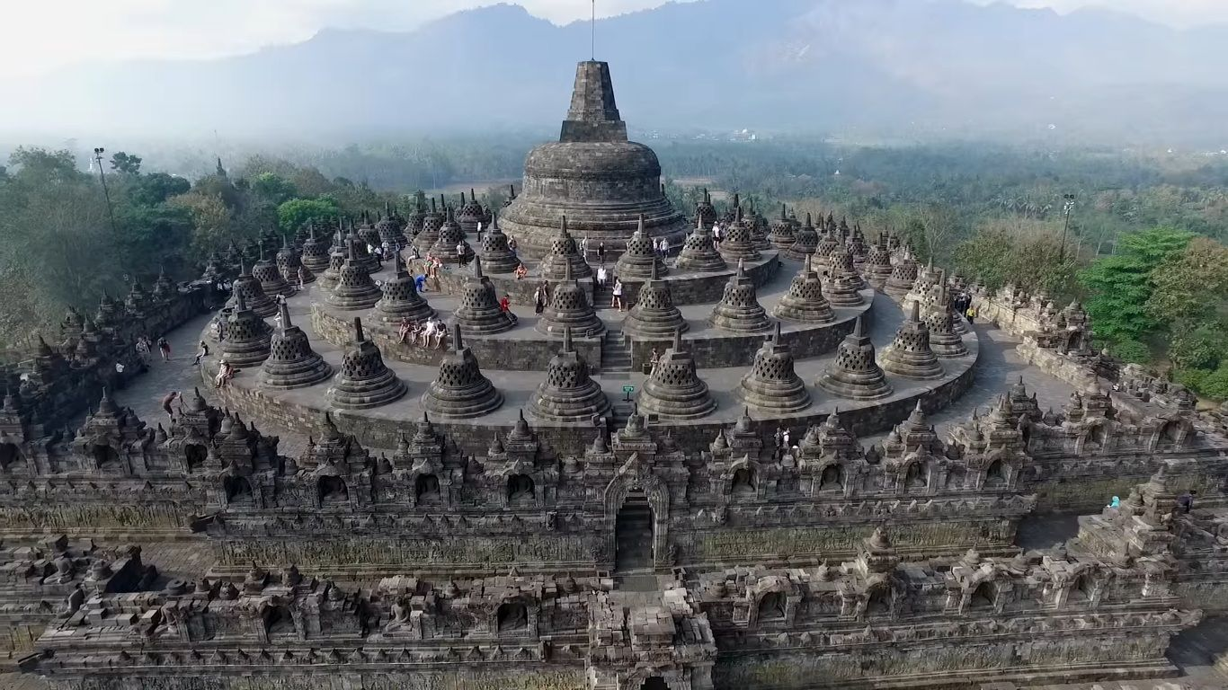**Day 2 Borobudur Temple**

**Spiritualism and Borobudur: A Sacred Journey Through the Buddhist Cosmos**

**Where?**

Borobudur is located in **Magelang, Central Java**, not far from Yogyakarta. It is the **largest Buddhist temple in the world**, and beyond its architectural wonder, it is a **deeply spiritual site** tied to ancient Buddhist cosmology, meditation, and Javanese mysticism.

**1. A Mandala in Stone**

Borobudur is more than a temple — it is a **three-dimensional spiritual map** of the Buddhist path to enlightenment. It represents a **mandala**, a sacred diagram used in meditation and spiritual practice.

The structure reflects **three levels of spiritual consciousness**:

1. **Kamadhatu (the world of desires)** – The base: Symbolizes human life bound by passions and karma.
2. **Rupadhatu (the world of forms)** – The middle terraces: Represents spiritual discipline and detachment from physical desires.
3. **Arupadhatu (the formless world)** – The circular upper platforms: Symbolizes the ultimate state of enlightenment, where the soul is free from form and desire.

Pilgrims traditionally walk **clockwise around each level**, meditating on the **reliefs** and **statues of Buddha**, gradually ascending toward spiritual liberation.

**2. Spiritual Pilgrimage and Meditative Practices**

* Pilgrims from across the world come to Borobudur, especially during **Vesak (Waisak)**, the most sacred day in Buddhism, to celebrate the **birth, enlightenment, and death of the Buddha**.
* Visitors often engage in **walking meditation**, **chanting**, and **silent reflection**, using the temple’s path as a meditative journey.
* The **sunrise at Borobudur** is considered spiritually uplifting, symbolizing awakening and enlightenment.

**3. Borobudur and Javanese Mysticism (Kejawen)**

Though Borobudur is a Buddhist temple, local **Javanese spiritualism (Kejawen)** has also left its mark:

* Many Javanese view Borobudur as a **powerful spiritual energy center**, not limited to one religion.
* **Meditation, tirakat (fasting for spiritual power)**, and **ziarah (pilgrimage)** are practiced by spiritual seekers who come for inner guidance or blessings.
* Some mystics believe Borobudur is aligned with **ley lines** or **cosmic energies**, and it serves as a spiritual “portal” for enlightenment.

**4. Local Myths and Mystical Beliefs**

* Folklore says Borobudur was built by **giants or spiritual beings**, due to its mysterious construction.
* Some stories tell of **hidden chambers** or **magical stones** with spiritual powers.
* Local mystics (often called **dukun** or **spiritual adepts**) may use the site during certain nights for **rituals and meditation**.

**In Summary:**

**Borobudur is not just a monument—it’s a spiritual experience.** Its layered structure reflects the Buddhist path to enlightenment, but its sacred atmosphere also draws Javanese mystics, seekers of inner wisdom, and those who feel the energy of the ancient stones. Whether through Buddhist teachings or Javanese spiritualism, Borobudur invites visitors to explore **the deep connection between the self, the universe, and the divine**.

**Planning Day 2 Borobudur Temple**Wake up at 07:00  
08:00 breakfast, breakfast consisting of fruit, juice, jamu, bread, toppings, nassi, and traditional snacks.  
09:00 Departure from Homebase to Borobudur temple.  
11:00 Workshop Eugine at Buroburu temple  
14:00 Depature to Traditional Restaurant   
14:00 Lunch at Traditional Restaurant  
15:00 Back to Homebase   
19:00 Dinner at homebase   
20:00 Group meeting workshop Eugine  
21:00 Massage   
22:00 Sleeping

__________________________________________________________________________________

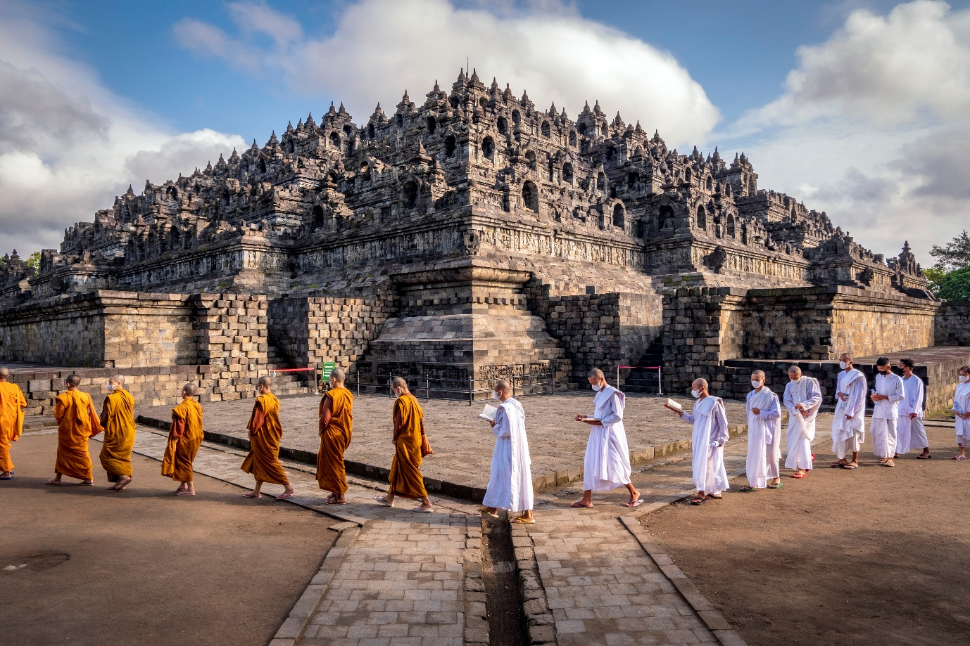

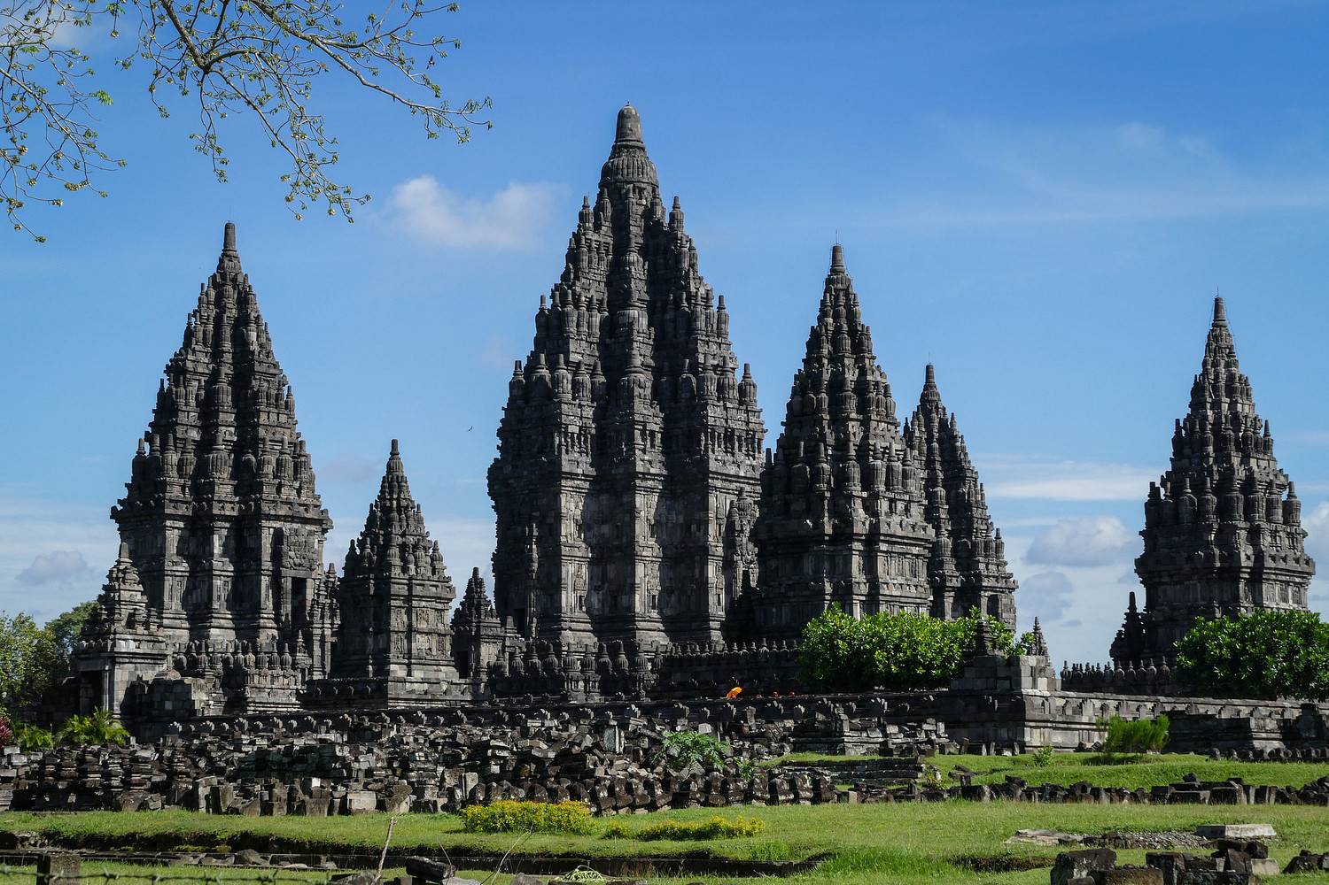**Day 3. Prambanan temple**

**\**

**Spiritualism and Prambanan: A Sacred Dance Between Gods and Mystics**

**Where?**  
Prambanan, or Candi Rara Jonggrang, is located just 17 kilometers northeast of Yogyakarta. As the largest Hindu temple complex in Indonesia, Prambanan stands as a testament not only to divine architecture but also to the profound spiritual traditions of Hinduism and Javanese mystical belief systems.

**1. A Temple to the Trimurti**

Prambanan is dedicated to the Hindu trinity: **Brahma (the Creator), Vishnu (the Preserver), and Shiva (the Destroyer)**. Each main temple is aligned to a specific deity, creating a cosmic balance of creation, preservation, and dissolution — the cycle of existence.

* **Shiva Mahadeva** is the tallest and central temple, symbolizing supreme consciousness and transcendence.
* The layout forms a **mandala-like compound**, with smaller temples surrounding the main structures, reflecting Hindu cosmology where Mount Meru stands at the center of the universe.
* Spiritual seekers often view the site as a metaphor for inner transformation — from chaos to cosmic order, from ego to the divine Self.

**2. Spiritual Practices and Ritual Pathways**

* Though Prambanan is not an active place of worship today, **devotees and spiritual pilgrims still walk the grounds**, performing **pradakshina** (clockwise circumambulation) in silent reflection.
* During sacred festivals such as **Nyepi** or **Galungan**, offerings are quietly placed near the statues, blending Hindu devotion with Javanese spiritual rites.
* The **Ramayana Ballet**, performed at the temple under moonlight, is more than art — it is a **ritual reenactment** of dharma (cosmic law) triumphing over adharma (chaos), awakening ancient spiritual vibrations.

**3. Prambanan and Kejawen Mysticism**

Like Borobudur, Prambanan is also embraced by **Kejawen**, the indigenous spiritual path of the Javanese:

* **Dukuns** (Javanese shamans) sometimes visit Prambanan at night to perform **tirakat** (austerities) seeking visions, strength, or divine messages.
* The site is believed to be aligned with **sacred ley lines** connecting volcanic peaks like Mount Merapi with the Indian Ocean — forming a mystical triangle of energy.
* Spiritual adepts believe **Shiva’s temple radiates the strongest power**, guiding those who seek inner awakening and connection to the divine masculine force.

**4. Myths and Mystical Lore**

* According to legend, **Rara Jonggrang**, the princess after whom the temple is named, was turned to stone after defying a prince's magical temple-building task. Her statue now stands as **Durga Mahisasuramardini**, the slayer of demons.
* Locals believe her spirit still lingers, and some claim to hear whispers or feel intense energy during full moons.
* Certain stones and carvings are said to **emit warmth** or subtle vibrations — leading to beliefs that the temple holds **hidden spiritual technology or gateways** to higher realms.

**In Summary:**

Prambanan is not just an ancient relic — it is a **living symbol of spiritual union**, where divine mythology, architectural genius, and mystical practice converge. To walk its grounds is to journey through time, across dimensions, and into the sacred dance of creation and dissolution. For both Hindus and Javanese spiritualists, Prambanan offers a place to remember the divine origin of the soul and its eternal rhythm with the cosmos.

**Planning Day 3. Prambanan temple**Wake up at 07:00  
08:00 breakfast, breakfast consisting of fruit, juice, jamu, bread, toppings, nassi, and traditional snacks.  
09:00 Departure from Homebase to Prambanan temple.  
11:00 Workshop Eugine at Prambanan temple  
14:00 Depature to Traditional Restaurant   
14:00 Lunch at Traditional Restaurant  
15:00 Back to Homebase   
19:00 Dinner at homebase   
20:00 Group meeting workshop Eugine  
21:00 Massage   
22:00 Sleeping

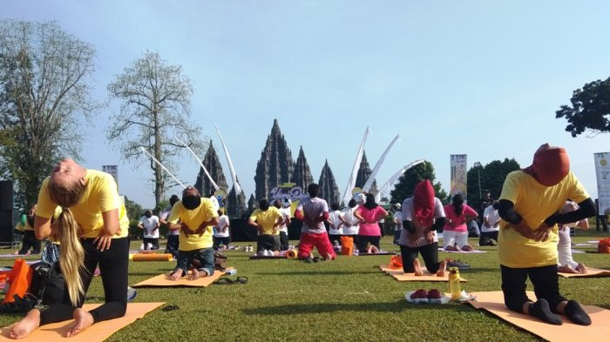

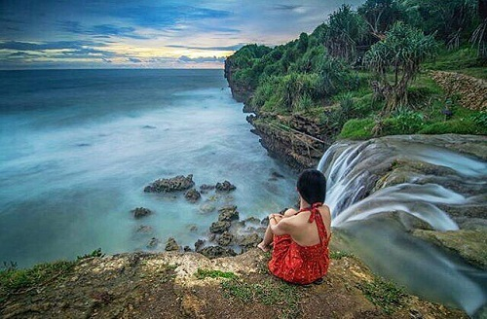**Day 4. Pantai Jogan**

**Spiritualism and Pantai Jogan: Where Waterfalls Meet the Soul**

**Where?**  
Pantai Jogan is a hidden gem on the southern coast of Yogyakarta, located in Gunungkidul. Unlike most beaches, Pantai Jogan is known for a rare natural phenomenon: a **waterfall that plunges directly into the sea**, blending the power of the mountains with the spirit of the ocean. This sacred meeting point has long been a site of quiet reflection, ancestral reverence, and Javanese spiritualism.

**1. The Sacred Confluence: Waterfall and Sea**

Javanese spiritual traditions often revere natural intersections — where land meets water, or sky meets earth — as **places of power**. At Pantai Jogan, the waterfall symbolizes **the descent of divine energy**, while the sea represents the **cosmic unconscious**.

* The waterfall is believed to carry **purifying energy** from the mountains, blessing all it touches before merging with the sacred southern ocean, or **Segoro Kidul**.
* According to local mystics, standing beneath the waterfall (especially at dusk) **cleanses the aura**, and **connects the soul with ancestral spirits** carried by the sea breeze.

**2. Rituals and Inner Pilgrimage**

Though lesser known than Borobudur or Prambanan, Pantai Jogan holds deep spiritual value for **practitioners of Kejawen** and local shamans.

* Some spiritual seekers undertake a **"tirakat air"** (water vigil), sitting silently beneath the fall at night or during the Javanese *weton* birth cycle, to seek clarity or guidance.
* Before important life transitions — marriage, fasting periods, or meditation retreats — **bathing in Jogan’s waters** is seen as a symbolic rebirth.
* Small offerings of **jasmine flowers, coins, or coconut husks** are often placed in the water or cast into the sea as a message to the **Queen of the South Sea**, Ratu Kidul, the revered ocean spirit in Javanese mythology.

**3. Mystical Energies and Ratu Kidul**

Pantai Jogan lies along the southern coastline, which is considered the spiritual domain of **Ratu Kidul**, the powerful sea goddess in Javanese mysticism.

* Some believe that **Jogan’s waterfall is a sacred “gateway”**, where Ratu Kidul communicates with the land.
* Spiritual adepts, especially **dukun wanita (female shamans)**, may use the area to **channel dreams, visions, or healing prayers**, especially during high tide or full moon.
* On special nights, locals report unusual sightings — green lights near the water, fragrant winds, or dreams of the sea queen, interpreted as spiritual invitations or warnings.

**4. Folklore and Hidden Meanings**

* One tale tells of a wandering monk who meditated for 100 days beside the waterfall and was **blessed with the ability to heal with touch**.
* Another legend claims that if you hear the waterfall “singing” like a woman, it means the **spirits are welcoming your presence**.
* The rocks behind the fall are said to have **symbols resembling old Javanese script**, now eroded, believed to be mantras left by ancient sages.

**In Summary:**

Pantai Jogan is not just a scenic spot — it is a **spiritual threshold** between worlds. Here, the waterfall is a channel of divine energy, and the ocean a vessel of timeless mystery. Whether you come to purify the self, to feel the breath of ancient spirits, or simply to listen to the sacred sound of falling water, Pantai Jogan invites you to witness the **eternal dialogue between nature and the soul**.

**Planning Day 4. Pantai Jogan**   
Wake up at 07:00  
08:00 breakfast, breakfast consisting of fruit, juice, jamu, bread, toppings, nassi, and traditional snacks.  
09:00 Departure from Homebase to Pantai Jogan  
11:00 Workshop Eugine at Pantai Joganmeditation and Silat workshop on top of the waterfal  
14:00 Depature to Traditional Restaurant   
14:00 Lunch at Traditional Restaurant  
15:00 Back to Homebase   
19:00 Dinner at homebase   
20:00 Group meeting workshop Eugine  
21:00 Massage   
22:00 Sleeping

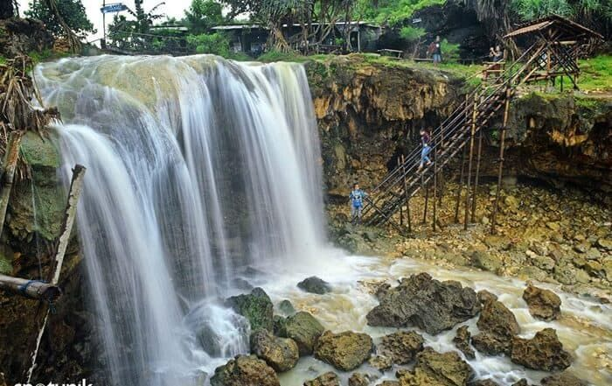

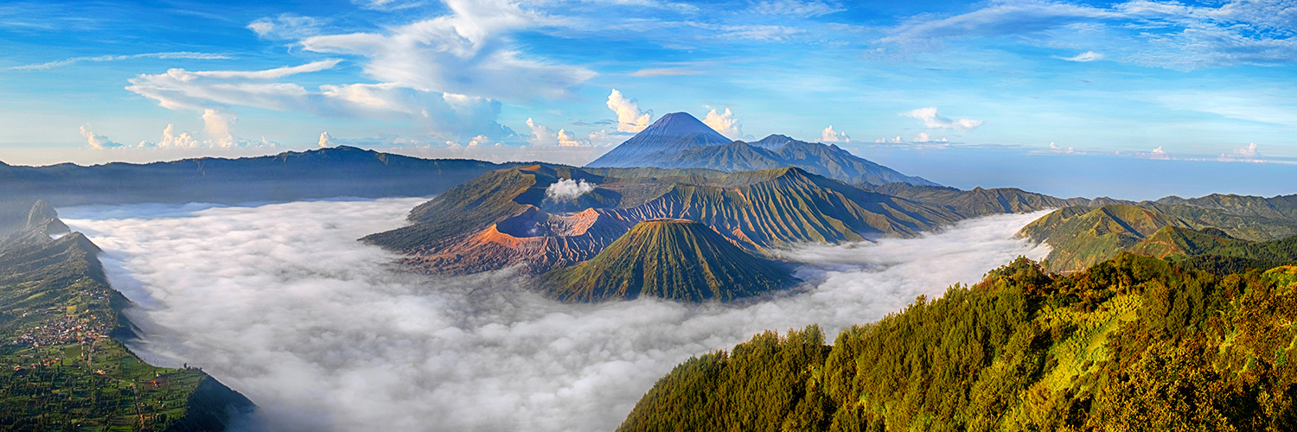

**MALANG**

**Spiritualism in Malang, East Java: Between Nature, Tradition, and Mysticism**

Malang, a highland city in East Java, is not only known for its beautiful landscapes and cool climate but also for its **rich spiritual traditions** rooted in **Javanese mysticism**, **Islamic practices**, **animism**, and **local folklore**.

**Kejawen and Javanese Mysticism**

Just like in Yogyakarta, **Kejawen** plays a central role in Malang's spiritual life. It focuses on:

* **Spiritual harmony with nature**, ancestors, and the divine.
* Practices such as **meditation (semadi)**, **fasting (tirakat)**, and **ritual offerings**.
* Many villagers in Malang still observe **rituals of thanksgiving (selamatan)** or **rituals for the land and spirits (ruwatan)**.

**2. Dukun and Paranormal Beliefs**

* **Dukun (shamans)** or **spiritual healers** are commonly sought for healing, protection from curses (santet), or spiritual advice.
* Some dukuns are respected **kebatinan (inner power)** practitioners, believed to have special abilities such as reading the future, communicating with spirits, or neutralizing black magic.
* Malang has stories of **santet** (witchcraft), often feared in rural areas. Protection rituals and talismans are part of the spiritual culture.

**3. Sacred Places and Natural Sites**

Malang is surrounded by spiritually significant locations, including:

* **Mount Bromo** (shared with nearby regions): A sacred volcano for both **Tenggerese Hindus** and Javanese mystics.
* **Mount Kawi**: A mystical pilgrimage site. It is believed to be a place of powerful spiritual energy. Many visit for **meditation**, **fortune-seeking**, or to perform **rituals to deceased Chinese and Javanese spiritual figures**.
* **Cemeteries of Wali and spiritual leaders**, like **Mbah Ratu Ibu** and **Eyang Djugo**, are often visited for **ziarah (spiritual pilgrimage)**.

**4. Islamic Mysticism (Tasawuf)**

* Many Javanese Muslims in Malang follow **Sufi traditions** that emphasize **inner spiritual development**.
* **Pesantren (Islamic boarding schools)** in the area sometimes teach **Sufi practices**, including **dzikir (remembrance of God)** and **wirid (repeated prayers)**.
* This spiritual form of Islam blends with local culture, making it both mystical and culturally grounded.

**5. Ghost Beliefs and Supernatural Stories**

* Malang is rich in **folklore and ghost stories**—haunted buildings, sacred trees, or mystical forests where spirits (makhluk halus) dwell.
* People often leave **offerings at crossroads, trees, or rivers** to appease spirits.
* Traditional ceremonies may be held to cleanse spaces or protect against negative spiritual forces.

**In Summary:**

Spiritualism in Malang is a **living tradition** that blends **ancient Javanese wisdom**, **mystical Islam**, and **local supernatural beliefs**. People in both rural and urban parts of Malang maintain a quiet respect for the unseen world, seeking balance and harmony through rituals, meditation, and deep connection with nature and ancestral spirits.

**Planning Day 5. Malang**Wake up at 07:00  
08:00 breakfast, breakfast consisting of fruit, juice, jamu, bread, toppings, nassi, and traditional snacks.  
09:00 Departure from Homebase to Malang Hotel Tugu by train or Bus, Lunch and drinks will be included.  
17:00, arrival hotel Tugu,   
18:00 Meeting and guide tour hotel tugu  
19:00 Dinner Hotel Tugu  
20:00 massage  
21:00 Sleeping

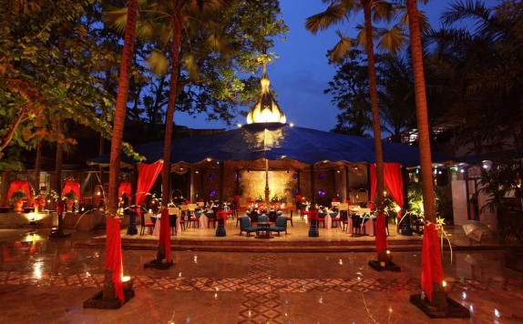

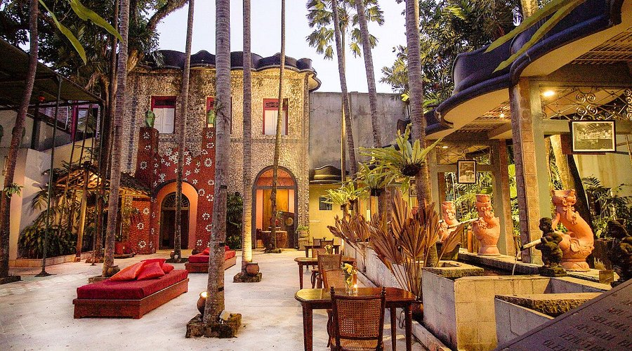

**Day 6 Mount Gunung Kawi**

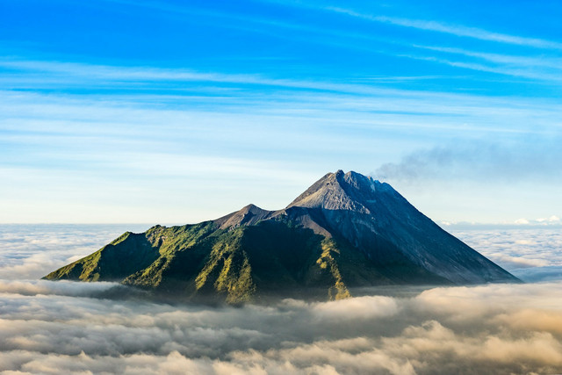

**Spiritualism and Gunung Kawi: The Mountain of Miracles and Ancestral Spirits**

**Where?**  
**Gunung Kawi** (Mount Kawi) is located near Malang, East Java, and is one of the most mystical and spiritually charged places in Indonesia. Nestled among lush hills, this sacred site is home to temples, ancient graves, and shrines believed to hold **supernatural powers**. It draws pilgrims, seekers of fortune, and mystics from across the archipelago.

**1. A Sacred Site of Syncretism**

Gunung Kawi is unique because it blends **Javanese mysticism (Kejawen)**, **Islamic saint veneration**, **Hindu-Buddhist cosmology**, and **Chinese Taoist influences** into one sacred space.

* The heart of the site is the **tomb complex of Eyang Jugo and Eyang Sujo**, two revered spiritual figures believed to possess powerful blessings.
* Visitors pray at multiple shrines and **burn incense**, offer **flower petals, coins, cigarettes, and food**, each offering holding symbolic meaning—respect, abundance, connection to the unseen.
* The mountain is considered a **“pusat rejeki”** — a spiritual center of prosperity, where sincere prayers can attract good fortune and divine guidance.

**2. Spiritual Pilgrimage and Personal Offerings**

* Pilgrims often come at night or early morning to **avoid crowds and enter a meditative state**, with silence and humility.
* Many undergo **tirakat** (fasting and ritual silence) for days before visiting, enhancing their spiritual receptivity.
* A popular belief is that those who come with **pure hearts and clear intentions** will receive **rejeki nomplok** — unexpected blessings, often in the form of wealth, healing, or inner peace.

**3. Mysticism, Fortune, and the Unseen**

Gunung Kawi is famed for its **supernatural energy**, and stories abound of **sudden business success**, **healing of chronic illnesses**, or **strange visions** after visiting the site.

* **Eyang Jugo**, a former advisor to Prince Diponegoro, is believed to have attained **moksha** (spiritual liberation) here and now blesses those seeking protection and wealth.
* Many pilgrims leave **written wishes or business cards** at his tomb, asking for help in love, trade, or fate.
* Spiritual practitioners say the area is surrounded by **jin baik (benevolent spirits)** who act as guardians and messengers.

**4. Rituals, Numbers, and Nights of Power**

* Pilgrims often visit on **Jumat Kliwon**, **Selasa Legi**, or during the **1st of Suro** in the Javanese calendar, considered potent spiritual nights when the veil between worlds is thin.
* Offerings are placed according to numerological beliefs — **9 incense sticks, 7 coins, or 3 kinds of fruit**, all aligned with ancient Javanese metaphysical principles.
* Some believers take home **blessed water, earth, or flowers** from the site to protect their homes or energize their businesses.

**In Summary:**

Gunung Kawi is not just a pilgrimage site — it is a **living spiritual ecosystem**, where ancient Javanese traditions blend with modern spiritual needs. Whether you come to seek wealth, healing, or simply to be in the presence of deep mystical energy, Gunung Kawi invites every soul into communion with the **unseen forces of the universe and the ancestral wisdom of Java**. In this quiet mountain temple, the boundary between the material and the metaphysical disappears, revealing the sacred threads that bind spirit, destiny, and devotion.

**Planning Day 6 Mount Gunung Kawi**   
Wake up at 06:00  
07:00 breakfast ala cart   
08:00 Departure from Hotel to Kunung kawi   
10:00 Workshop Eugine at Kunung Kwi mountain   
14:00 Depature to Traditional Restaurant   
14:00 Lunch at Traditional Restaurant  
15:00 Back to Hotel Tugu   
16:00 Workshops Egine  
19:00 Dinner at   
20:00 Group meeting workshop Eugine  
21:00 Massage   
22:00 Sleeping

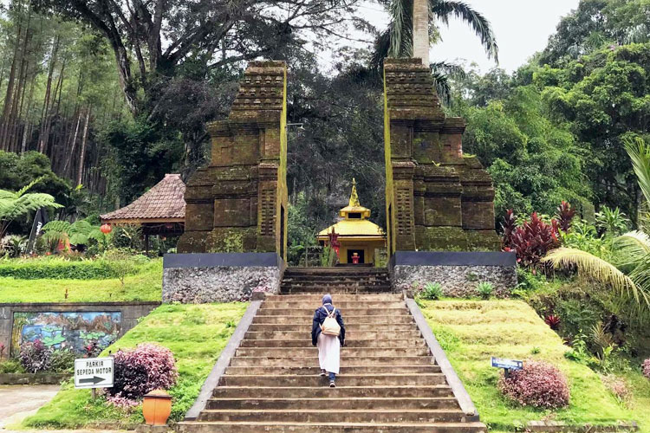

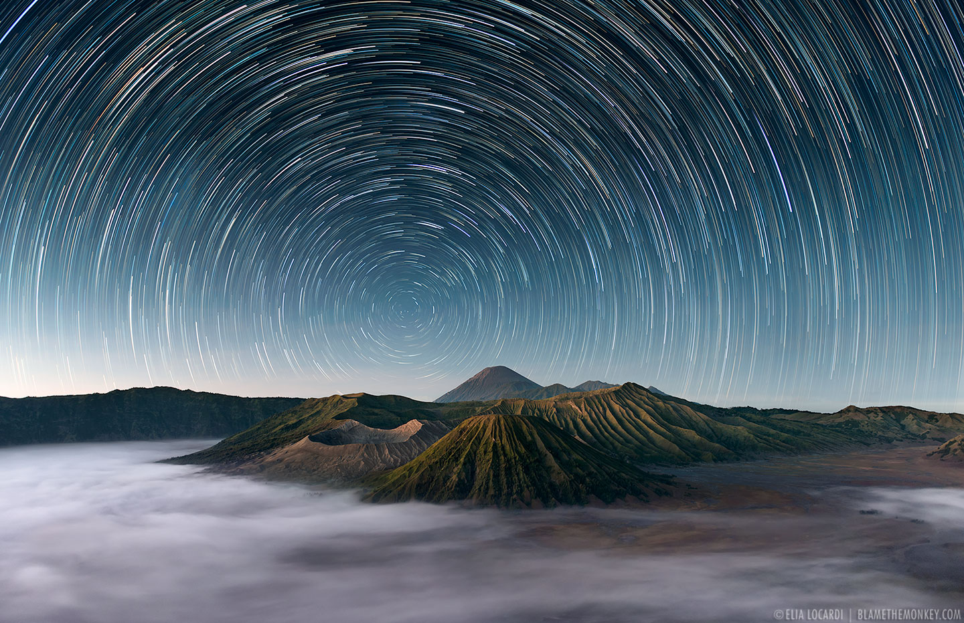**Day 7 Mount Bromo**

**Spiritualism and Mount Bromo: The Fiery Breath of the Divine**

**Where?**  
Mount Bromo, located in East Java within the vast Tengger Caldera, is one of Indonesia’s most iconic and sacred volcanoes. Named after **Brahma**, the Hindu god of creation, Mount Bromo is not only a natural wonder, but also a **living altar of spiritual energy**, deeply embedded in both **Tenggerese Hinduism** and **Javanese mysticism**.

**1. The Sacred Volcano of Creation**

To the Tenggerese people — descendants of the ancient Majapahit kingdom — **Mount Bromo is a holy site**, believed to be the dwelling place of divine forces.

* The volcano is part of the **Bromo Tengger Semeru National Park**, where **Mount Semeru**, the tallest mountain in Java, is seen as the “seat of the gods.”
* **Mount Bromo's crater**, always smoldering, is seen as **the breath of Brahma** — a direct manifestation of life, destruction, and cosmic renewal.
* For the Tenggerese, the mountain is a **gateway between the physical world and the divine**, and its eruptions are interpreted as spiritual messages.

**2. Yadnya Kasada: A Living Ritual**

Each year during the full moon of the 12th month in the Tenggerese calendar, locals gather for the **Yadnya Kasada festival**, a sacred offering ritual held at the crater of Bromo.

* **Offerings of rice, vegetables, flowers, livestock, and prayers** are thrown into the smoking crater to **appease the gods and ancestral spirits**.
* This tradition honors the legend of **Roro Anteng and Joko Seger**, a noble couple who made a pact with the mountain spirit to bear children in exchange for a sacrifice — a pact that birthed both the Tenggerese people and the Kasada ritual.
* The act is both **a symbol of gratitude and surrender**, where earthly possessions are given back to the divine source.

**3. Meditative Ascent and Pilgrimage**

Climbing Mount Bromo before sunrise is not just a tourist activity — for many, it is a **spiritual pilgrimage**.

* The journey through **the Sea of Sand** (Lautan Pasir), a vast volcanic desert, is likened to crossing a spiritual void — a **symbol of emptiness before awakening**.
* At the top, as the sun rises over the crater and neighboring peaks, many visitors practice **silent meditation, breathwork, or prayer**, seeing the moment as one of **cosmic clarity and spiritual rebirth**.
* The sulfur-scented winds are said to **purge negativity**, and the view from Bromo’s rim offers not only beauty, but deep inner stillness.

**4. Mystical Beliefs and Javanese Spiritualism**

While Mount Bromo is rooted in Hindu tradition, it is also a place of **Kejawen mysticism** and Javanese metaphysical practices:

* Spiritual seekers and **dukun (shamans)** often come to Bromo on specific nights, such as **Jumat Kliwon** or **Suro**, to **commune with mountain spirits or seek visions**.
* The volcano is believed to possess **a magnetic aura**, attracting energies from **other realms**, and serving as a **place of initiation or spiritual testing**.
* Some mystics meditate by the crater's edge to **contact ancestral beings**, or perform **tirakat** (ritual fasting and silence) for enlightenment.

**In Summary:**

Mount Bromo is more than a volcano — it is a **living temple of fire**, where myth, ritual, and nature intertwine. For centuries, it has called pilgrims, mystics, and wanderers to witness the sacred forces of creation and surrender. Whether through Hindu offerings, Javanese meditation, or personal reflection, Bromo remains a place where the **earth meets the heavens**, and where the soul can feel the raw, untamed breath of the divine.

**Planning Day 7 Mount Bromo**Wake up at 06:00  
07:00 breakfast ala cart   
08:00 Departure from Hotel to Mount Bromo  
11:00 Workshop Eugine at Bromo peakmeditation and vibration awareness   
14:00 Depature to hotel plataran Bromo  
15:00 Lunch at hotel  
16:00 workshops Egine  
19:00 Dinner at Resort   
20:00 Group meeting workshop Eugine  
21:00 Massage   
22:00 Sleeping

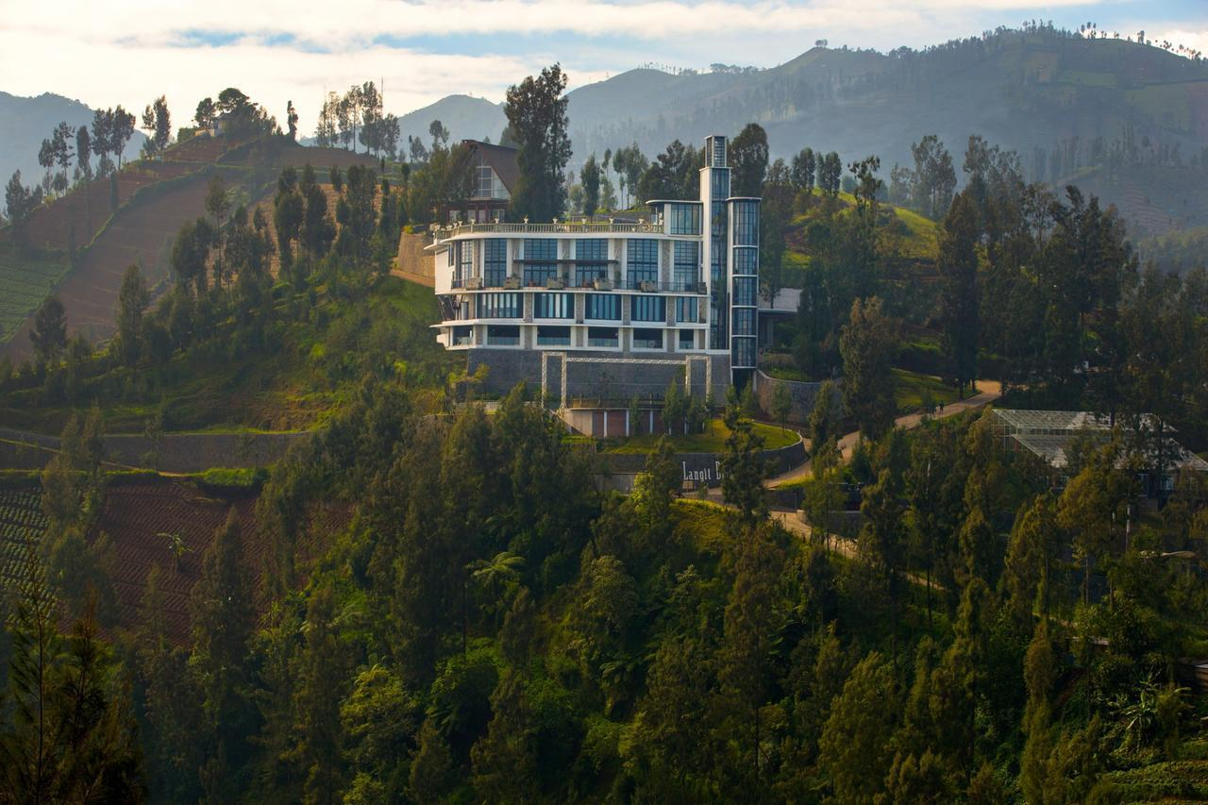

**Day 8 Mount Sumeru**

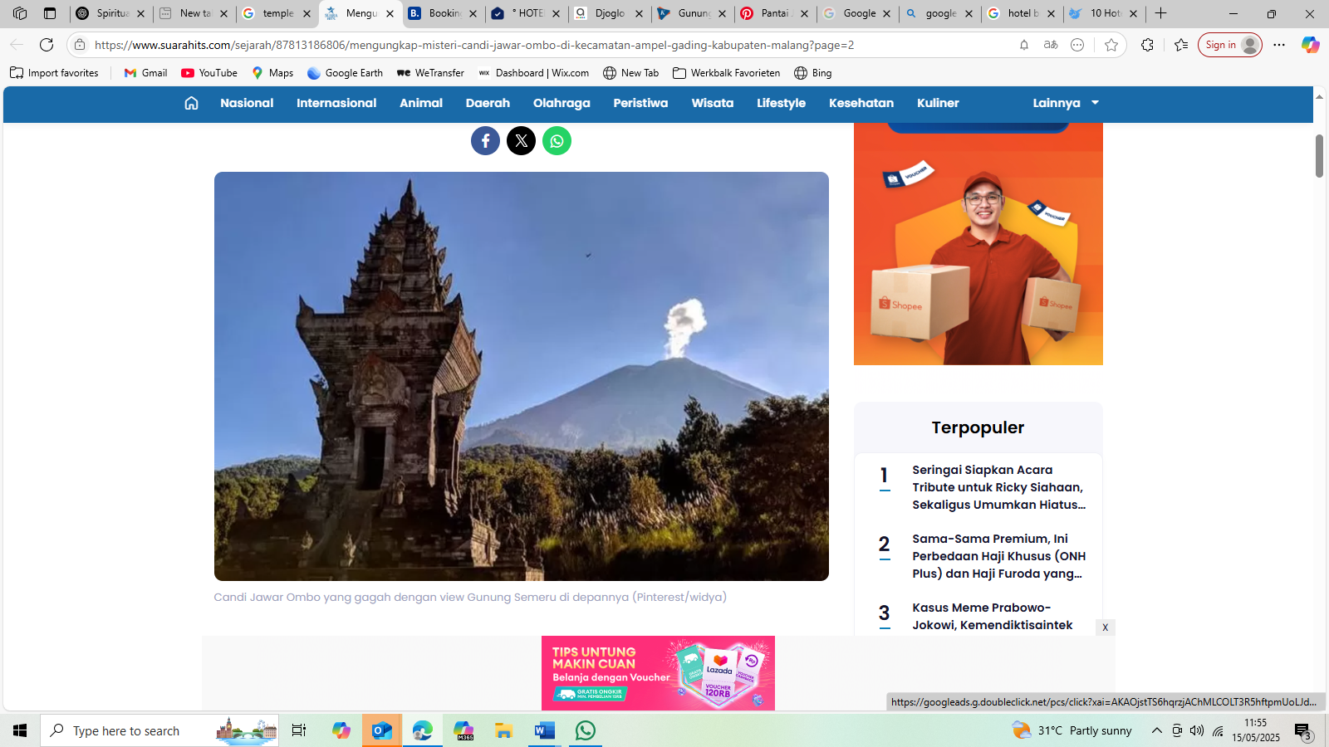

**Spiritualism and Mount Semeru: The Throne of the Gods and the Path of the Soul**

**Where?**  
**Mount Semeru** (Gunung Semeru), located in East Java, is the **highest volcano on the island** (3,676 meters above sea level) and one of Indonesia’s most sacred and powerful mountains. Known as **Mahameru** (Great Meru), it is revered as the earthly representation of **Mount Meru**, the mythological axis of the universe in Hindu-Buddhist cosmology. For centuries, Semeru has been a destination not only for adventurers but for **spiritual seekers**, **hermits**, and **pilgrims in search of the divine**.

**1. Mount Meru on Earth: A Cosmic Axis**

In ancient Javanese-Hindu belief, Mount Semeru is **the sacred mountain brought from India by the gods** to stabilize Java. It represents **the spiritual center of the world**, where gods descend and the soul may ascend.

* Semeru is linked to the **Trimurti** — Brahma (creation), Vishnu (preservation), and Shiva (destruction) — with the mountain itself seen as a **manifestation of Shiva**, the god of transformation and transcendence.
* The volcano’s periodic eruptions are interpreted as **divine messages**, reminders of nature’s cycles and the impermanence of life.

**2. Pilgrimage and Inner Journey**

Climbing Semeru is not only a physical challenge — it is a **spiritual ascent**, symbolic of the **soul’s journey toward enlightenment**.

* Many pilgrims walk in **silence or recite mantras** as they ascend, treating the journey as **a moving meditation**.
* The climb passes through sacred waypoints:
  + **Ranu Pani** (start of the soul’s journey),
  + **Ranu Kumbolo** (a sacred lake symbolizing emotional reflection),
  + **Kalimati** (the place of trials), and finally
  + **Mahameru peak** (the place of self-realization).
* The **sunrise at the summit** is seen as a moment of divine contact — a **spiritual rebirth**, where light meets breath and the seeker stands between sky and earth.

**3. Mysticism and the Spirit of Shiva**

* Mount Semeru is believed to be inhabited by **spiritual guardians** and **Shivaic energies**. Many mystics or **dukun gunung** (mountain shamans) have lived in the area, entering deep meditation to receive visions or spiritual instruction.
* Some climbers report feeling an **overwhelming sense of presence**, hearing whispers in the wind, or dreaming of **ancestral figures or fire gods**.
* Offerings of **incense, rice, and flowers** are often made at the summit or near the crater edge, as a sign of respect to the divine forces believed to reside there.

**4. Rituals, Warnings, and Sacred Codes**

* Before climbing, locals advise **asking permission** from the mountain by silently touching the earth at Ranu Pani and offering a short prayer.
* It is believed that **those with arrogance or impure intentions** may face obstacles — from getting lost to strange weather changes — as a way the mountain “tests” or “rejects” the seeker.
* On special days like **Suro (Javanese New Year)** or **Jumat Kliwon**, climbers and mystics often hold quiet vigils around the lake or summit, aligning with **cosmic energies**.

**In Summary:**

Mount Semeru is not just the highest point in Java — it is a **spiritual summit**, where the myths of gods merge with the path of the human soul. Its landscape is both breathtaking and humbling, and its energies invite deep introspection, reverence, and transformation. For those who climb with an open heart and sacred intention, Semeru becomes a teacher — reminding us that the path to the divine is steep, fiery, and full of grace.

**Planning Day 8 Mount Semeru**Wake up at 06:00  
07:00 breakfast   
08:00 Departure from Hotel to Bromo Mount Semeru  
11:00 Workshop Eugine at Temple mount Sumeru, meditation and vibration awareness   
14:00 Lunch at Mount Semeru  
15:00 Departure mount Sumeru to Miami hotel   
17:00 workshops Egine  
19:00 Dinner at Traditional restaurant Kepanjen   
20:00 Back to hotel   
21:00 Massage   
22:00 Sleeping

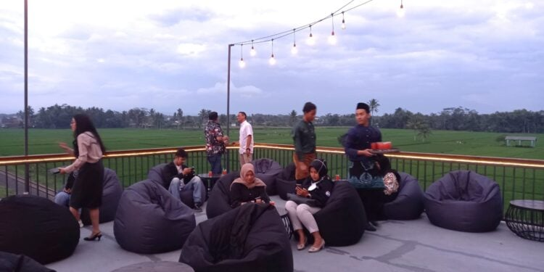

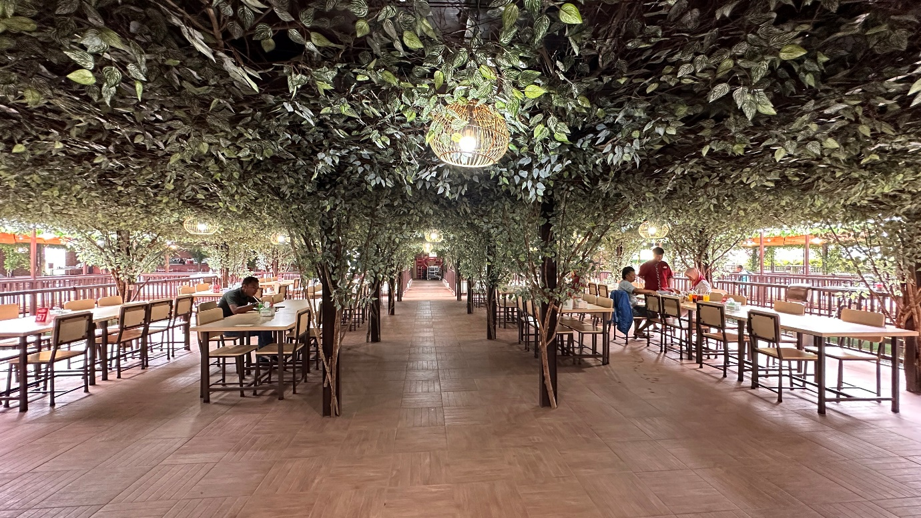

**Day 9 pantai kondang merak malang**

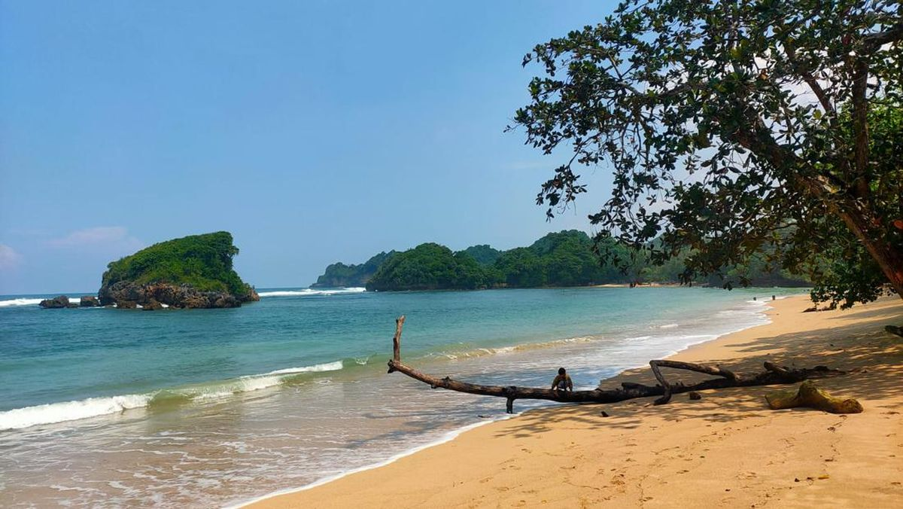

**Spiritualism and Pantai Kondang Merak: The Sacred Shore of Silence and Sea Spirits**

**Where?**  
**Pantai Kondang Merak** is a tranquil beach located in the southern part of **Malang, East Java**. Tucked away behind lush forests and quiet hills, it remains one of the **least disturbed and most mystical** beaches in the region. Unlike the crowded tourist spots, Kondang Merak is a **place of spiritual retreat**, where **land, ocean, and sky** blend in harmony, inviting seekers into a deep state of reflection and connection with the **unseen forces of nature**.

**1. A Sacred Landscape of Serenity**

Kondang Merak is named after the **wild peacocks (merak)** that once frequented the area, believed to be **spirit messengers or guardians** in Javanese mythology.

* The beach's peaceful energy, gentle waves, and sacred silence make it a **natural meditation ground**, perfect for those practicing **tirakat** (spiritual fasting and solitude).
* The surrounding cliffs and coastal forests are seen by locals as **"pintu gaib"** (hidden doors), where the **spirit world and the physical world softly touch**.
* Javanese spiritualists say the beach’s aura is ideal for **cleansing negative energy**, especially at sunrise and sunset, when the elements are in balance.

**2. Ratu Kidul and the Southern Sea**

Like many beaches along Java’s southern coast, Kondang Merak is under the spiritual dominion of **Ratu Kidul**, the mystical Queen of the South Sea.

* Offerings of **flowers, incense, batik cloth, and coconut water** are sometimes placed near the shoreline during **Friday Kliwon** or **1 Suro**, to show respect or ask for spiritual blessings.
* Pilgrims seeking clarity, emotional healing, or protection often sit quietly facing the ocean, whispering prayers believed to be carried to **Ratu Kidul’s underwater palace**.
* According to local legend, **the tide’s rhythm is her breath**, and those who listen with their heart may hear **messages in the waves**.

**3. Rituals, Meditation, and Sacred Nights**

* **Night vigils** (tirakat malam) are performed on the beach by spiritual adepts and dukun, especially on mystical nights in the **Javanese calendar**.
* Some seekers bury their feet in the sand or sit in **a ring of sea stones**, entering silent meditation to commune with the **energies of water and earth**.
* Others bring **personal items or written prayers**, asking the spirits of the sea and land to remove sorrow, illness, or bad luck from their lives.

**4. Folklore and Invisible Guardians**

* Locals speak of **“penjaga pantai”** (beach guardians), unseen beings that protect Kondang Merak and test the intentions of those who visit.
* Some have told of **dreams or visions** after visiting, receiving guidance from a lady in green — a common representation of Ratu Kidul.
* It's said that **those with sincere hearts are never alone** at Kondang Merak; the spirits of the beach walk beside them, offering silent companionship.

**In Summary:**

Pantai Kondang Merak is more than a peaceful coastal escape — it is a **spiritual sanctuary**, where the Javanese soul connects with the ancient forces of sea, sky, and spirit. Whether through solitary meditation, whispered prayers to Ratu Kidul, or simply walking barefoot on its sacred sands, Kondang Merak offers a space to release burdens, **listen inward**, and align with the **unseen rhythms of the universe**. In its quiet, a profound presence waits — not loud or forceful, but deeply real.

**Planning Day 9 pantai kondang merak malang**

07:00 breakfast   
08:00 Departure from Hotel Miami to the beach   
10:00 arrival pantai Goa China, cave visit and sound therapy in the cave   
12:00 departure to pantai kondang merak  
12:30 Tent base camp at the beach  
13:00 Lunch at the beach   
14:00 Workshops Eugene  
18:00 Diner   
19:00 Camp fire at the beach   
20:00 Workshop Eugene at the beach   
22:00 Sleeping

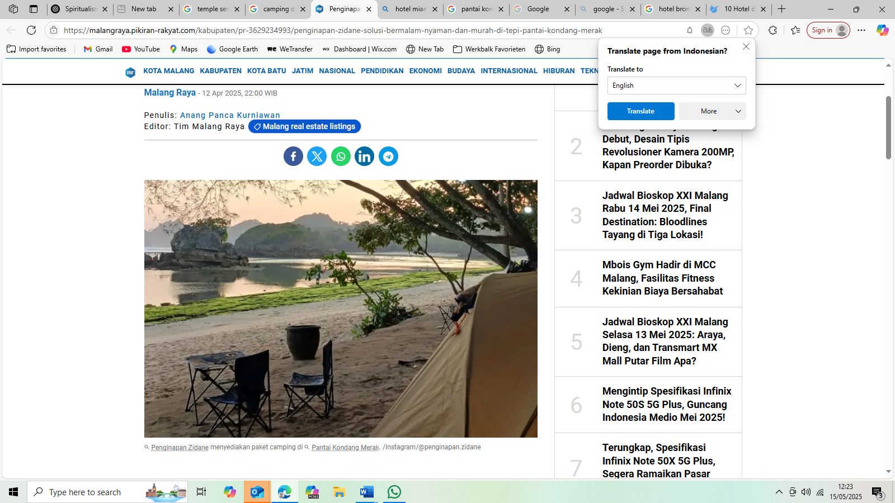

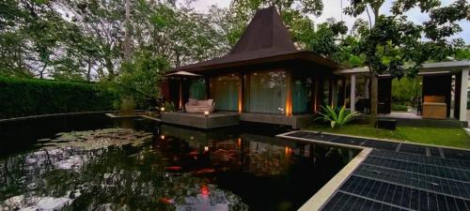**Day 10 DJoglo resort, in Araya Malang**

**Planning Day 10 DJoglo resort, in Araya Malang**

07:00 breakfast at beach   
08:00 workshop Eugine at the sea   
12:00 Lunch at the beach   
13:00 to Djoglo resort Araya Malang   
15:30 Arrival Djoglo Resort Araya Malang   
17:00 Group meeting   
18:00 Diner at Djoglo Resort Araya Malang  
19:00 Massage   
20:00 Sleeping

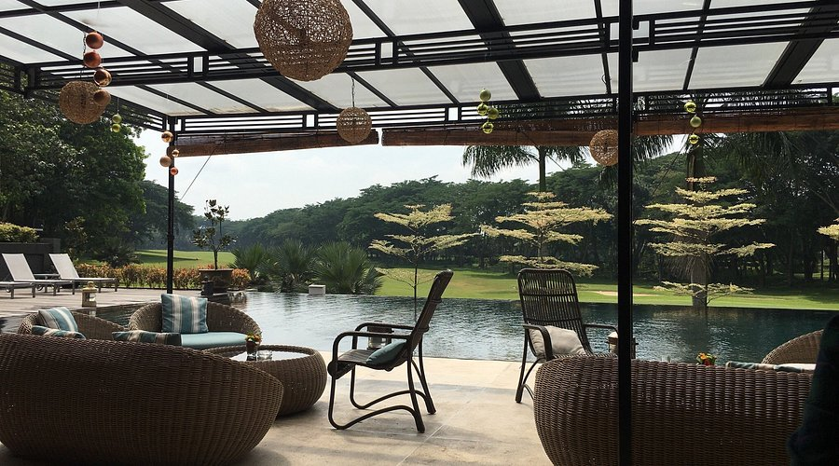

**Day 11, Sumba Lelewatu Resort Sumba**

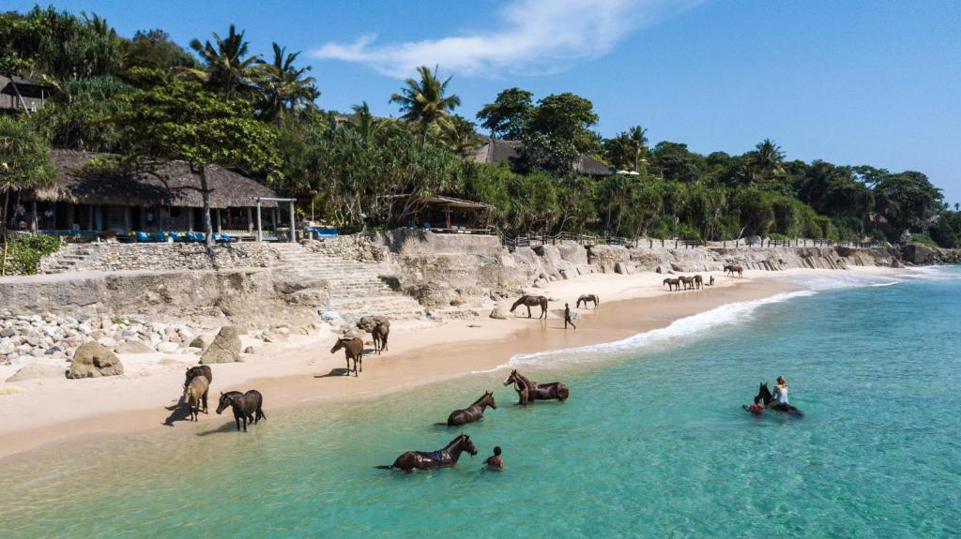

**Spiritualism and Sumba: The Island Where Ancestors Walk and Nature Speaks**

**Where?**  
**Sumba**, an island in eastern Indonesia, is a land of rugged hills, megalithic tombs, sacred rituals, and living traditions. Unlike many other regions of Indonesia, **Sumba retains a deeply rooted indigenous spiritual belief system** called **Marapu**, where the world of the living and the ancestors are in constant communion. Here, **spiritualism is not a practice — it is life itself**.

**1. Marapu: The Spirit of the Ancestors**

The cornerstone of Sumbanese spiritual life is **Marapu**, an ancient animistic belief system that centers on **ancestral worship, the forces of nature, and balance between the physical and spiritual realms**.

* **Marapu** means “the hidden and the revealed” — it refers to **divine spirits, ancestral souls, and sacred natural forces**.
* Every tree, stone, and river is believed to house a **living spirit**. Mountains are considered the dwelling place of ancestral gods.
* Rituals are guided by **Rato** (priests), who act as intermediaries between the people and the **ancestral world**, maintaining harmony and cosmic order.

**2. Megalithic Tombs and Living Legacy**

Sumba is one of the last places in the world where **megalithic tomb-building is still practiced**. These massive stone graves are more than burial sites — they are **gateways to eternity**.

* Families build **stone tombs** to honor their deceased, often accompanied by **buffalo or horse sacrifices**, to ensure the spirit's journey into the next world.
* It is believed that the **spirits of the ancestors remain close**, guiding their descendants and influencing everyday life — from health and farming to dreams and omens.
* Visitors often describe a **powerful energy** near these tombs, a sense of time standing still and the veil between worlds thinning.

**3. Rituals, Pasola, and the Dance of Fate**

Sumba’s most famous spiritual ritual is the **Pasola**, a dramatic horseback spear fight that takes place at the beginning of the harvest season.

* Pasola is not a sport — it is a **sacred ritual to honor Marapu**, call for a fertile season, and **spill symbolic blood** to nourish the earth.
* The event is guided by signs from nature: **the appearance of sea worms (nyale)** determines the date and is read as an **omen from the ancestors**.
* Even conflict and bloodshed are seen as part of the **balance of life**, honoring death as a necessary part of renewal.

**4. Nature as the Sacred Text**

* In Sumba, **the land itself is sacred**. There are **forbidden forests**, **sacred springs**, and **rocks shaped by spirits**.
* Offerings of betel nut, cloth, and food are placed in these locations, accompanied by **chants or whispered prayers** to maintain spiritual balance.
* The people of Sumba believe that **to harm nature is to anger the ancestors**, and so **sustainability and reverence** are interwoven with tradition.

**In Summary:**

Sumba is not only a land of extraordinary landscapes — it is **a spiritual realm where the past lives on**, and where **ritual, nature, and ancestors remain deeply connected**. In every stone, every wave, and every breath of wind, the voice of the divine can be heard. Through Marapu, the people of Sumba continue to **live in harmony with both the seen and unseen**, showing us that spirituality is not something separate from life — **it is life**.

**Planning Day 11, Sumba Lelewatu Resort Sumba**  
  
07:00 breakfast   
08:00 to airport Surabaya  
11:00 fly to Tambokala Sumba  
15:40 Arrival Tambokola Sumba   
16:00 to Lelewatu Resort Sumba  
17:00 Arrival resort   
18:00 Diner at Resort   
19:00 Eugine workshop   
20:00 Massage   
21:00 Sleeping

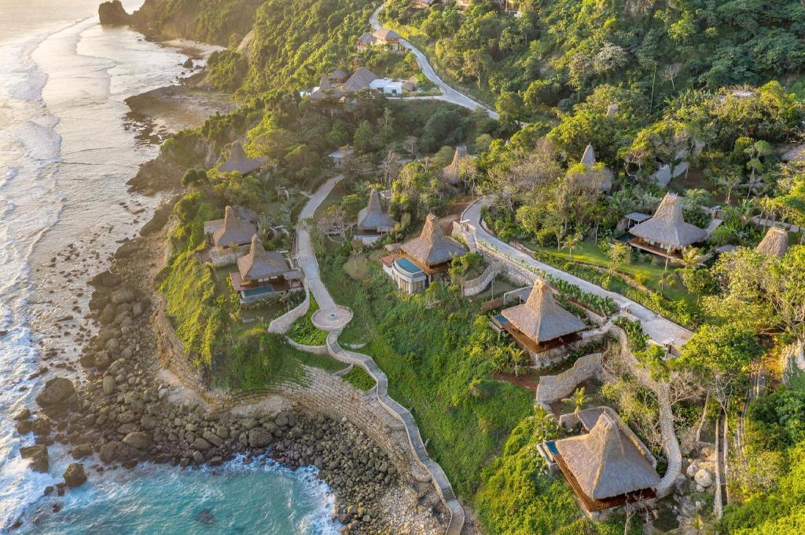

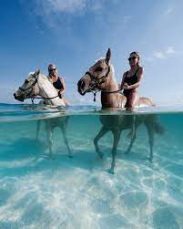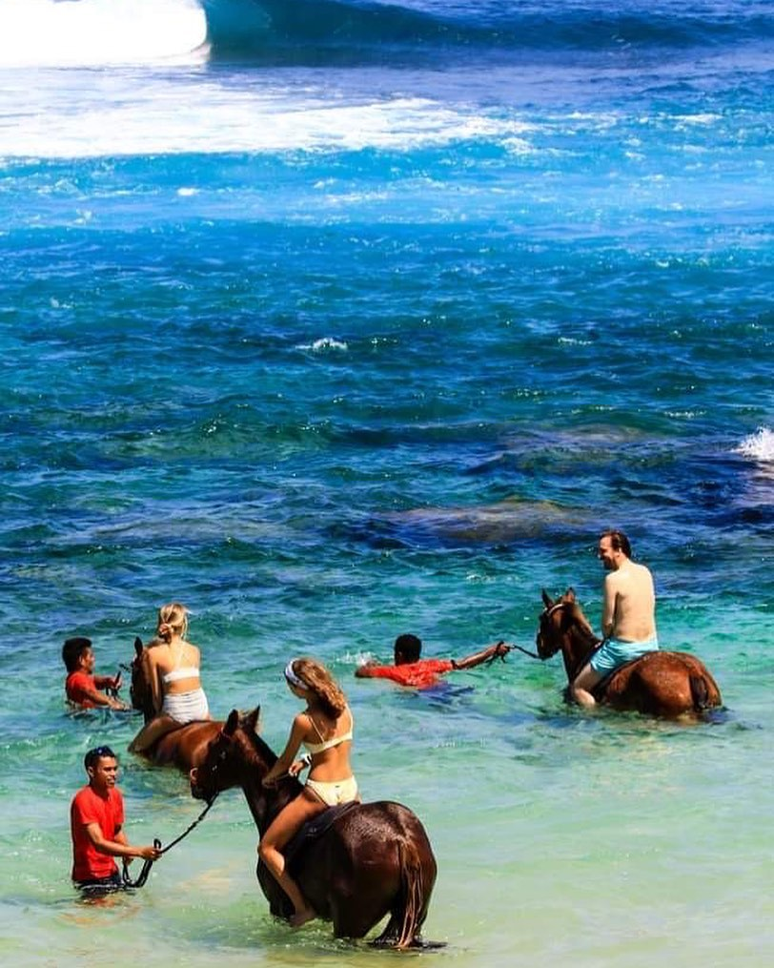**Day 12, Sumba swimming with wild horse and horse driving**

**Swimming with Horses in Sumba: A Healing Ritual Between Water, Spirit, and Soul**

**Where?**  
On the coasts of **Sumba, East Nusa Tenggara**, the rhythm of waves meets the gentle strength of **Sumba’s native horses**, creating a deeply moving and unexpectedly therapeutic experience: **swimming with horses in the sea**. More than a recreational activity, for locals and some healers, this act is viewed as a **ritual of balance, emotional healing, and spiritual renewal**.

**1. The Horse as a Sacred Companion**

The **Sumba horse**, small, agile, and resilient, is more than an animal — it is a symbol of **freedom, ancestral strength, and harmony with nature**.

* Horses in Sumbanese tradition are used in **ceremonial battles like Pasola**, but they are also treated with respect, almost reverence, as **beings with spirit**.
* Swimming with a horse is believed by some **local healers (dukun or rato)** to **cleanse heavy energies**, especially for those burdened by grief, fear, or inner turbulence.
* The **bond between horse and human** in water becomes a metaphor: a surrender of control, a trust in nature, and a letting go of what weighs the soul down.

**2. The Sea as Healer and Portal**

The **southern seas of Sumba** are often seen as **sacred gateways** — associated with **Ratu Kidul** in broader Javanese belief, and in Sumbanese tradition, as places where **spirit and nature connect**.

* Entering the sea with a horse is done slowly, deliberately. As the horse wades in, the rider breathes deeply, syncing with the movement of the waves and the animal’s body.
* The water acts as a **natural conductor**, drawing out **emotional stress, fear, trauma, and spiritual blockages**.
* Local guides sometimes begin the experience with **a short prayer or offering**, asking the sea spirits for safety and healing.

**3. Therapeutic Benefits: Mind, Body, and Spirit**

* Physically, riding a horse in the water provides **gentle resistance and movement therapy**, helpful for those recovering from physical injury or needing stress release.
* Emotionally, the **soothing nature of the sea**, combined with the connection to the horse, promotes **calm, courage, and inner trust**.
* Spiritually, participants often describe a **sense of clarity and lightness**, as if the ocean and the horse “carried away” burdens they didn’t even know they held.

*"It felt like the horse knew my sadness and carried me through it,"* said one traveler.  
*"The sea became a mirror, and the horse became a guide."*

**4. Ritual and Reflection**

* Some travelers choose to bring **flower offerings** to leave in the sea after the swim, as a gesture of gratitude or a symbolic release of something they're ready to let go.
* Others sit quietly on the shore, letting the sound of waves and the presence of the horses become a **form of meditation**.
* Local practitioners sometimes incorporate the swim into **broader healing rituals**, including massage, herbal baths, or dream interpretation.

**In Summary:**

**Swimming with horses in Sumba** is far more than a unique activity — it is a **therapeutic ritual**, a dance of trust between human, animal, and ocean. In the embrace of saltwater and the rhythm of the horse’s body, one finds not only joy and awe, but healing. Here, the sacred and the simple unite — reminding us that sometimes, the most profound transformations come from simply **surrendering to nature’s gentle power**.

**Planning Day 12, Sumba swimming with wild horse and horse driving**

07:00 breakfast at beach   
08:00 departure to horse therapy   
10:00 horse swimming and touring   
13:00 lunch   
14:00 workshop Eugine   
16:00 Free time   
17:00 Back to resort   
18:00 Dinner at resort   
20:00 group meeting   
21:00 Massage

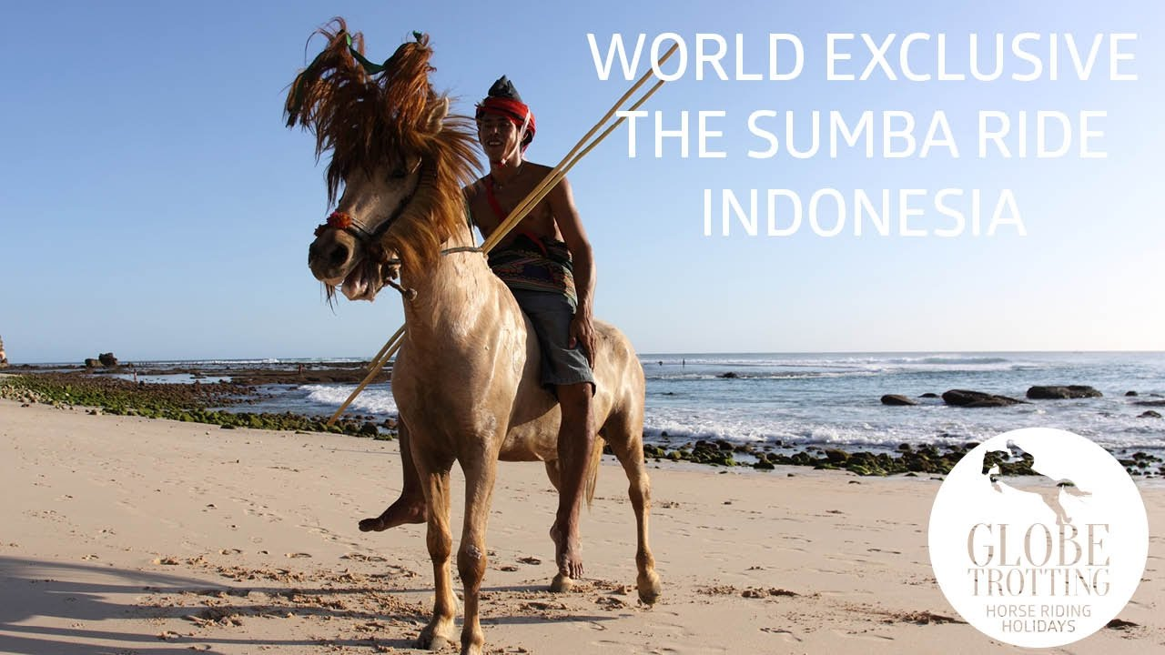

**Day 13, Sumba swimming with dolphins in the wild**

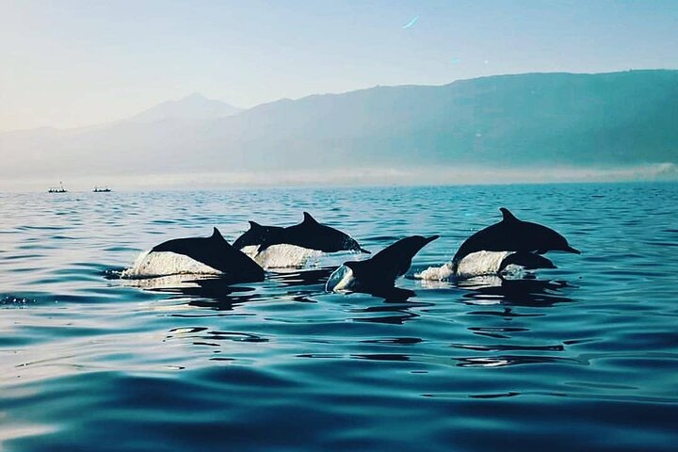

**While Sumba is known for its beautiful beaches and abundant marine life, including dolphins, the island doesn't offer structured "swim with dolphins" programs in the same way that some other destinations do. Instead, you can enjoy dolphin sightings and potentially snorkel or swim in the same waters with these amazing creatures in a more natural setting.**

**Swimming with Wild Dolphins: A Journey of Healing, Connection, and Inner Awakening**

**Where?**  
Across the tropical coasts of **Indonesia**, from **Lovina in Bali** to **Alor, East Nusa Tenggara**, the ocean becomes a sacred sanctuary for those seeking deeper healing. In these blue waters, **wild dolphins** swim freely — not as performers, but as sentient beings whose presence offers a **rare spiritual and therapeutic experience**. Swimming with them is not just an encounter with nature — it is often described as a **soul-awakening moment of pure connection**.

**1. The Dolphin as a Healer and Spirit Guide**

In many indigenous and spiritual traditions, **dolphins are considered spirit animals**, guides between the conscious and subconscious, between the human world and the spirit realm.

* Dolphins are associated with **joy, intelligence, harmony, and healing**. Their **echolocation clicks** and **gentle presence** are believed to have **balancing effects on human brainwaves**, helping restore emotional equilibrium.
* Shamans and traditional healers view dolphins as **keepers of ocean wisdom**, beings that communicate telepathically and recognize human intention.
* Children with trauma or individuals on spiritual quests often report feelings of **peace, safety, and euphoria** after even brief encounters.

**2. Swimming in the Wild: Respectful Encounters**

Unlike enclosed or artificial experiences, **swimming with wild dolphins** is based on **invitation, not control**. There is no guarantee — which makes the connection even more profound.

* Travelers often rise before dawn, entering the sea in silence. The moment the dolphins appear, the mood shifts — as if time slows and the heart opens.
* Some practitioners describe the dolphins' approach as **energy-based**: they often come closer to those who are **calm, open-hearted, and respectful**.
* Floating in the water, side by side with these beings, becomes a **wordless meditation** — a mirror into one’s emotional and spiritual state.

**3. Therapeutic Effects: Dolphin-Assisted Healing**

Scientific and anecdotal evidence suggests that **dolphin-assisted therapy** (DAT) can support healing in many ways:

* **Emotional release**: Their frequencies and sonar can gently **stimulate the vagus nerve**, triggering calm and sometimes emotional catharsis.
* **Mental clarity**: Dolphins’ presence often induces **alpha and theta brainwaves**, similar to deep meditation or altered states of consciousness.
* **Spiritual upliftment**: Many people report vivid dreams, spontaneous insights, or feelings of **oneness with the universe** after dolphin swims.

“When I swam with them, I didn’t feel separate from anything. It was like remembering who I really was.”  
— A seeker after a swim in Alor.

**4. Rituals, Intentions, and Ocean Prayer**

* Some spiritual guides suggest beginning the dolphin swim with a **water blessing** — placing flowers or saying a quiet prayer to the sea.
* Others encourage setting a **personal intention**: healing a wound, releasing fear, or opening the heart.
* After the swim, sitting quietly by the sea or journaling the experience helps integrate the **emotional and spiritual shifts**.

**In Summary:**

**Swimming with wild dolphins** is not a show — it’s a **gift**. A moment of **natural grace and healing**, where ego disappears and soul awakens. In the ocean’s embrace, guided by the playful, ancient intelligence of dolphins, one often finds not only joy but **a deep remembrance of inner peace and unity**. For those who listen with more than their ears, the dolphins **sing the song of healing** — and invite us to swim, not only in the water, but in the sacred current of life itself.

**Planning Day 13, Sumba swimming with dolphins in the wild**

07:00 breakfast at beach   
08:00 departure to boats for dolphin spotting (traditional)  
10:00 swimming, snorkelling   
13:00 lunch   
14:00 workshop Eugine   
16:00 Free time   
17:00 Back to resort   
18:00 Dinner at resort   
20:00 group meeting   
21:00 Massage

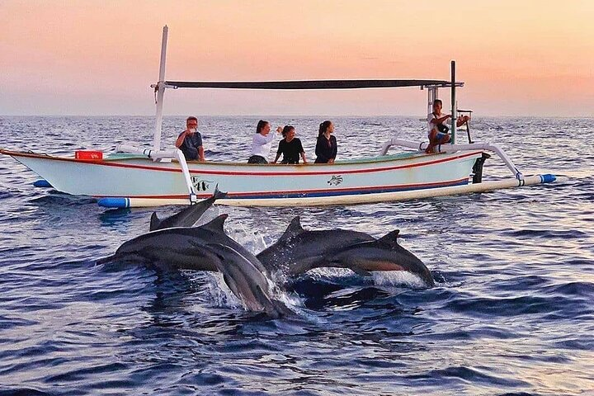

**Day 14, Sumba to Surabaya, Hotel Majapahit Surabaya MGallery**

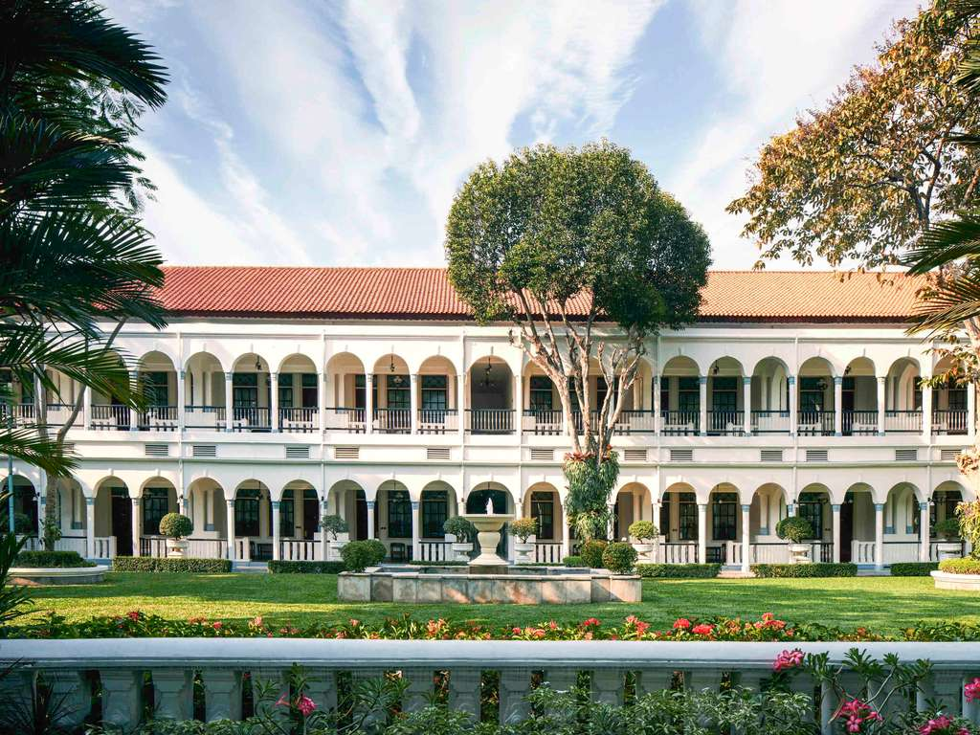

**Planning Day 14, Day 14, Sumba to Surabaya, Hotel Majapahit Surabaya MGallery**

08:00 breakfast at beach   
09:00 departure airport  
11:00 To Surabaya  
13:30 Arrival Surabaya   
14:30 Arrivel Hotel Majapahit Surabaya MGallery  
16:00 Group meeting training, and end event   
17:00 Diner at Hotel  
18:00 City tour Surabaya, to grand mall  
20:00 Back to hotel  
21:00 End of the tour